1. **WordPress auto password changed :**

Solution:

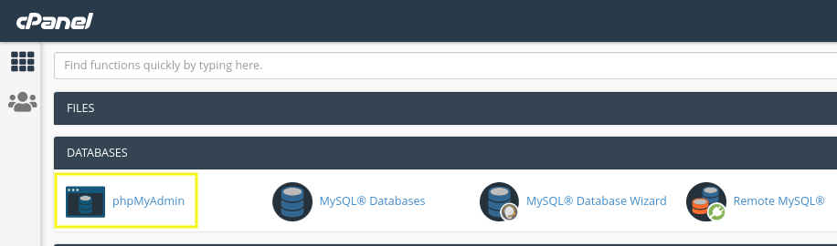

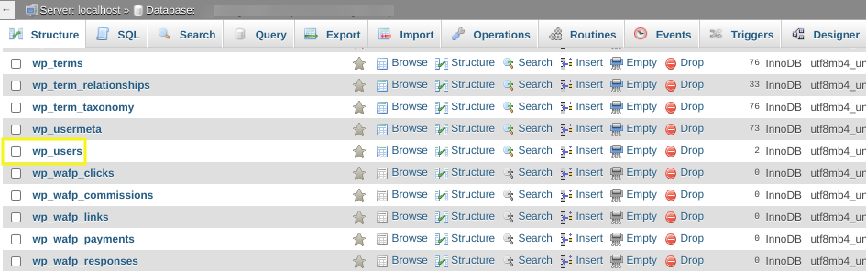

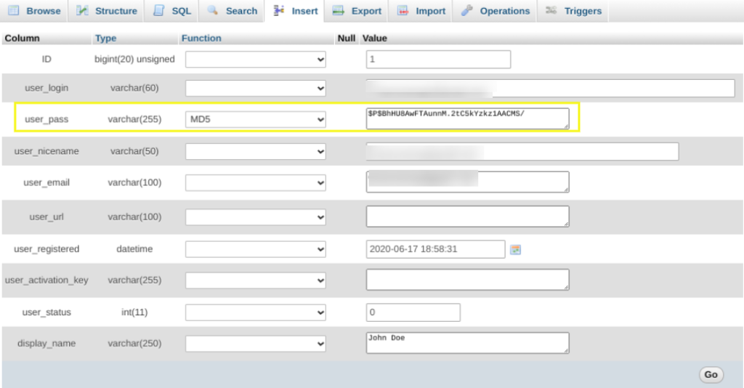

4. After you click the Browse icon, it will bring you to a page that lists **all the users registered on your WordPress site**. In this list, you can find the **username, user email, and encrypted password** associated with your account.

5. **Select the user** you want to change the password for, then **click on Edit.**

6. On the next page, you will be able to change your WordPress password in the user_pass section. Next to the **user_pass** you will see a long list of letter and numbers. **Select and delete this long string.**

7. **Type in the new password** that you want to use. Remember that it is case sensitive.

8. Once done, **select MD5 from the drop-down menu**. This step is important because **the MD5 selection will encrypt the password for you.**

9. **Double-check to ensure the password is correct and that MD5 has been selected.**

10. Save your changes by **clicking the Save, Update, or Go button** at the bottom of the page.

1. **WordPress maintenance error:**

Briefly unavailable for scheduled maintenance. Check back in a minute.’ error

**Solution: This error creates a .maintenance file in WordPress cpanel**

**- Just delete that file**

**It’ll start working.**

1. **Never Update any plugin in WordPress, It’ll take you in trouble**
2. **If any plugin get crash:**

**-Just remove the complete folder of that plugin inside WordPress cpanel “Plugins ” folder.**

1. **Connect WP SMTP mail with google workspace email**

**Solution: GO Google cloud console :**

Follow steps given in link below:

<https://wpmailsmtp.com/docs/how-to-set-up-the-gmail-mailer-in-wp-mail-smtp/?utm_source=WordPress&utm_medium=setup-wizard&utm_campaign=liteplugin&utm_content=Read%20how%20to%20set%20up%20the%20Gmail%20mailer#create-app>

1. **Connect WP SMTP mail with email created in godaddy or hostinger**

**Solution: GET SMTP details from the cpanel.**

1. **Define User Roles Menu display only after user login or logout:**

SOl: Groovy

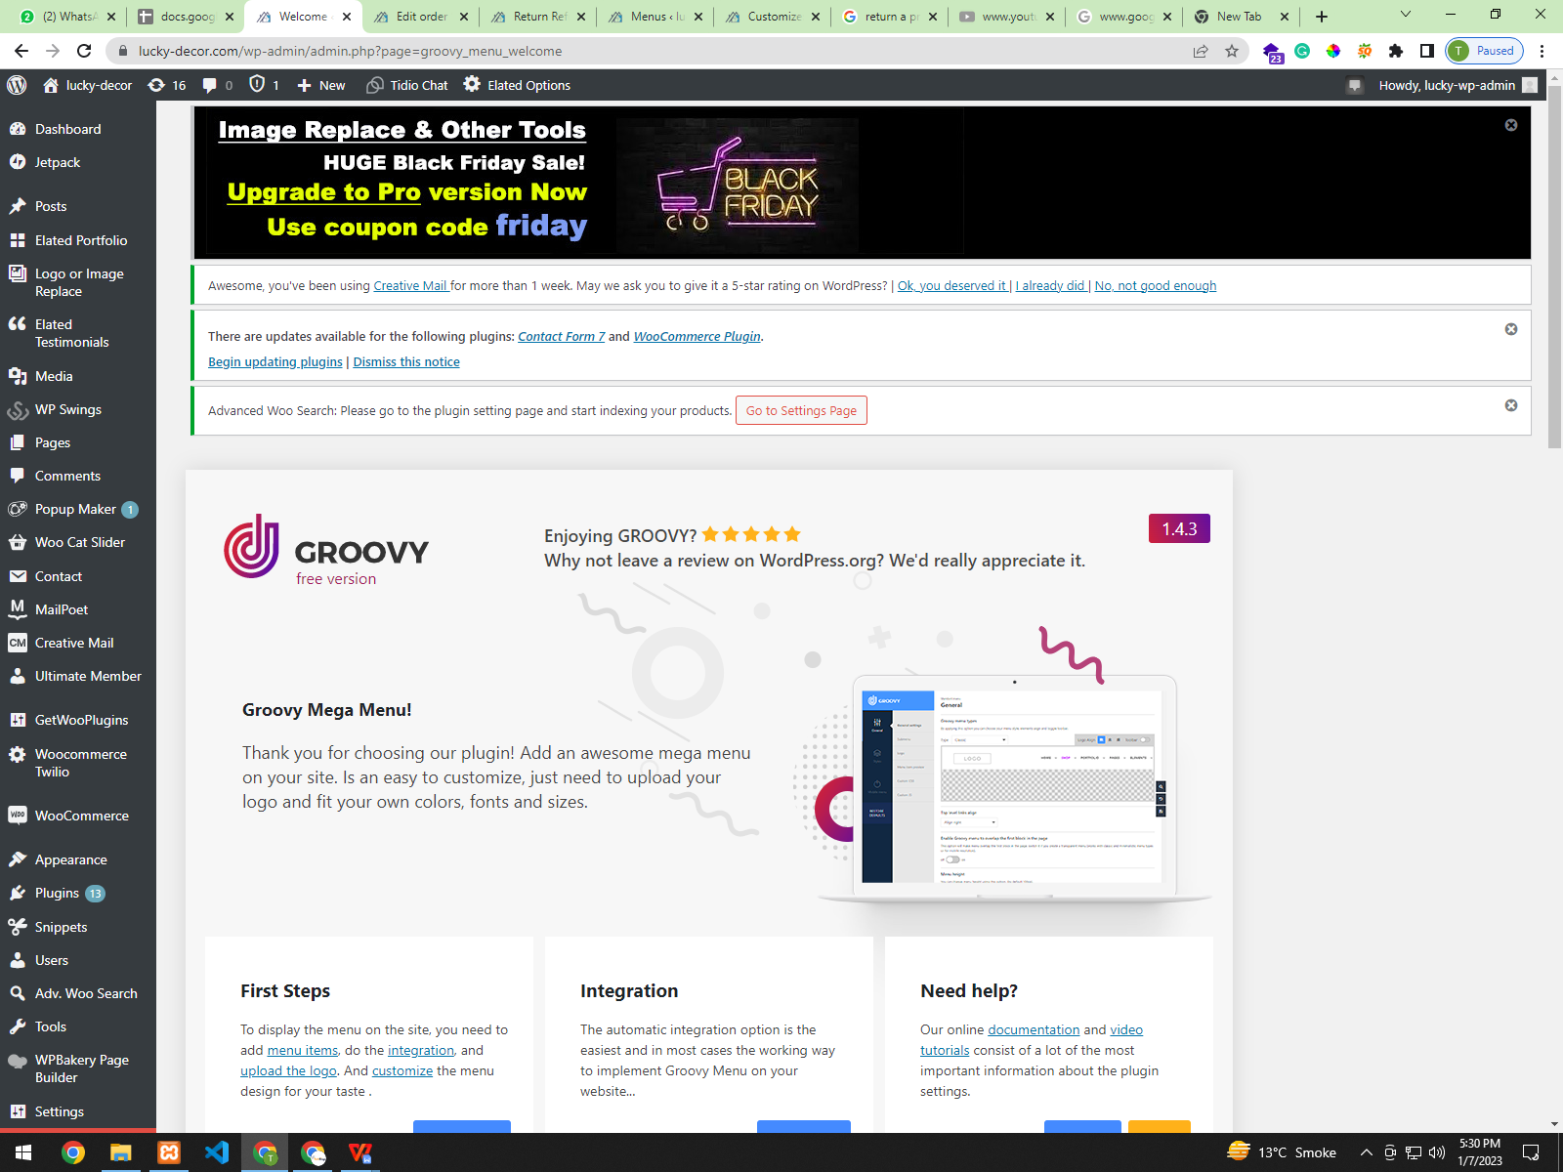

1. **Plugin : Custom Post Type UI**

**TO create custom texnomies for products such as shape, color, size, etc**

